 | 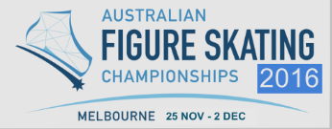 | 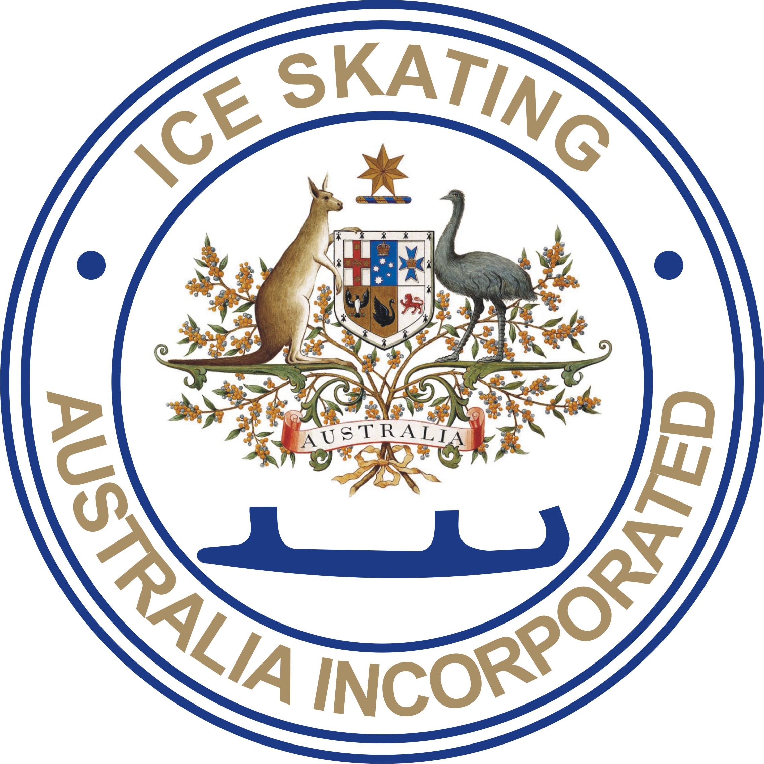

2016 AUSTRALIAN FIGURE SKATING CHAMPIONSHIPS
O’Brien Group Arena, Docklands, Melbourne
November 26th to December 2nd 2016
ANNOUNCEMENT
Organised by Ice Skating Victoria Inc. on behalf of Ice Skating Australia Incorporated.

ENTRIES: All competitors must enter via the online entry system on the AFSC website. Only those nominated by their home State Associations may enter. Pair and Dance entries should be entered at the same time. Home State Associations will be required to verify their members following the close of entries.

Each State shall be entitled to nominate up to four (4) entrants in each Championship event. The host State may nominate a fifth entrant in each event.

Reigning title holders may defend their titles without being counted in a State's quota in any event where defence of title is permitted.

The board of ISA may, in its absolute discretion, accept further entries for any event from any State.

The Australian Figure Skating Championships will be conducted as per ISU and ISA Regulations – refer www.isu.org and www.isa.org.au.

PPC must be lodged in accordance with the on line entry process.
Music Detail should be lodged in accordance with the on line entry process.

Closing date of entries: FRIDAY 21st OCTOBER

Revised PPCs will be accepted up until the starting order draws.

All State Associations must submit Entries by number by Friday 14th October
Singles Dance & Pairs competitor confirmation: ISV will email a list of all skaters who have registered online via the AFSC website to each State Association by Wednesday 19th October. Each State Association is to check the list and advise any changes to convenor@iceskatingvictoria.org.au by Friday October 21st.

Synchronized teams confirmation: ISV will email a list of all teams (and team numbers) who have registered online via the AFSC 2016 website to each State Association by Wednesday 26th October. Each State Association is to check the list and email any changes to convenor@iceskatingvictoria.org.au and the Chair - Synchronized Skating by Friday October 28th.

Payment of entry fees at point of entry via Paypal, Credit Card or EFT.

1. ENTRY FEES
Synchronized Skating Teams will receive a refund for the second banquet ticket following the close of entries.

Adult, Basic Novice A, Basic Novice B, and Intermediate (singles) 1 Program | $195.00 per skater
Advanced Novice, Junior, and Senior Singles (Ladies and Men) 2 Programs | $240.00 per skater
Pair Skating (Basic Novice, Advanced Novice, Junior, Senior) 2 Programs | $185.00 per skater
Adult Pair & Dance 1 Program | $170.00 per skater
Ice Dancing 2 Programs | $185.00 per skater
Adult Basic, Adult, Mixed Age, and Novice Synchronized Skating 1 Program | $185.00 per team member
Junior and Senior Synchronized Skating 2 Programs | $200.00 per team member

LATE ENTRIES
Entries may be accepted after the closing date up until the day before the first official draw, upon payment of double the entry fee for the particular event.

WITHDRAWAL/REFUNDS
For a withdrawal accompanied with a medical certificate before the commencement of the first Starting Order draw, refund of fees less 15%. For withdrawals after the STO Draw, NO refund is available for any reason.

2. PRACTICE
The Unofficial/Official practices for Synchronized Skating take place on Friday 25th November 2016 subject to finalisation of entries and schedule.

The Official practices for Synchronized Skating will begin on Saturday 26th November 2016 subject to finalisation of entries and schedule.

The Official practices for Adult sections will be held on Friday evening, 25th November 2016 subject to finalisation of entries and schedule.

Official practices for Singles, Pairs, and Dance sections will begin on Monday 28th November 2016 subject to finalisation of entries and schedules.

Unofficial Practice Ice will also be available. Booking details will be published separately.

3. MUSIC & PLANNED PROGRAM CONTENT
Programs will be skated to music of the skater’s choice and must comply with ISU requirements for music as applicable to Singles/Pairs/Dance & Synchronized.

Music must be uploaded via the link on the AFSC2016 website.
The MP3 music file should be named: Division – Skater Name – running time of music eg:
Novice Ladies_Free_Kristy_Skatername_2.48.mp3

A copy of Music MUST also be on a CD – only 1 track per CD - and available on request at the competition. All CDs MUST be clearly marked with the competitor’s name, event and music time. CDs must be of good quality and submitted in a separate case for each CD.

All competitors/teams are required to submit a Planned Program Content (PPC) Form and Music Form uploaded to the AFSC website.

4. DRAWS – ORDER OF SKATING & QUALIFYING
There will be a welcome party for the starting order draws for Synchronized Skating and Singles, Pairs and Ice Dancing Events on Friday 25th November 2016, in the upstairs bar area O’Brien Group Arena, Docklands. Time 6:00pm.

In accordance with ISA practice, for all events with a Short and Free Program, the intermediate starting order draw will not take place and the reverse order of the result after the Short Program/Short Dance/Pattern Dance will be the skating order for the Free Skate/Free Dance.

5. INSURANCE/LIABILITY
All members of State Associations are covered under the ISA National Insurance Policy while participating in the Championships. This Policy includes Sports Accident cover.
ISA and ISV assume no responsibility or liability for other persons in connection with these Championships.
ISA recommends that any person travelling to Victoria for the Championships considers personal travel insurance.

6. VENUE

O’Brien Group Arena
105 Pearl River Rd
Docklands VIC 3008
Phone: 1300 756 699

7. ENQUIRIES
Enquiries in the first instance should be directed to the convenor@iceskatingvictoria.org.au. Championship information including schedule and entry forms will be posted on the ISA website at www.isa.org.au and / or the AFSC website www.afsc2016.com please check both.

8. CHAMPIONSHIP BANQUETS
- Entry to both Championship Banquets will be by ticket only.
- The Synchronized Skating banquet will be held on the evening of Sunday 27th November 2016 at Etihad Stadium, 740 Bourke St, Docklands VIC 3008 from 7:00 pm to 11:00 pm. Synchronized competitors may attend free of charge; Only one ticket will be issued per skater regardless of how many synchronized events they compete in. Absolutely NO correspondence or discussion will be entertained on this matter.
- The Figure Skating banquet will be held on the evening of Friday 2nd December 2016 at the O’Brien Group Arena, 105 Pearl River Rd, Docklands VIC 3008, on 1st floor, from 7.00 pm to 11:00pm, Singles, Pairs and Dance competitors may attend this banquet free of charge; only one ticket will be issued per skater regardless of how many Figure Skating events they compete in. Absolutely NO correspondence or discussion will be entertained on this matter.
- Judges and Officials may buy banquet tickets at a discounted price.
- Other people wishing to attend the banquets will be able to buy tickets via AFSC website at www.afsc2016.com.
- All competitors (Synchronized Teams & Figure Skating), Judges, Officials and others wishing to attend the banquets should return the Banquet Booking Form by 11 November 2016 to indicate numbers attending.

9. COMPETITOR PHOTOGRAPHS FOR SOUVENIR PROGRAM
Photographs of competitors MUST be submitted by Monday 31st October 2016 for possible inclusion in the Souvenir Program.
- The method for submission is by electronic file (JPG files only - minimum file size 300dpi (a JPG of 200Kb or higher). The competitor’s name and event must accompany all electronic submissions and emailed to: andrew.taylor@iceskatingvictoria.org.au.

10. COACH ACCREDITATION
Only coaches accredited with the Australian Sports Commission may obtain championship accreditation.
No unaccredited Coaches or other support personnel of any description will be allowed rink-side during practice session or events. In the case of an international coach who has not had the opportunity to pursue ASC accreditation, the coach may make written application to APSA seeking APSA endorsement for the provision of championship accreditation upon review of evidence of qualifications submitted in English. Coaches may not access the judging stand at any time during practices or events.

11. RESULTS
The ISU Judging System will be used for all events.
Results will be displayed on the screen during each event.
Results will be uploaded to www.isa.org.au and www.afsc2016.com as soon as possible after each event.
ISA advises that all displayed and or announced results remain provisional until the actual result is certified by the segment referee and technical controller on the official result form. These official results will be displayed on the rink AFSC notice board at the rink.

12. ANTI-DOPING CONTROLS
Anti-Doping tests may be conducted in accordance with the ISA Anti-Doping Policy and ISU Anti-Doping Rules & Procedures. Competitors should ensure that they are aware of these rules and especially those regarding leaving the venue after an event.

13. AWARDS
13.1 SINGLES, PAIR SKATING, ICE DANCING (ISA RULE 517)
- Gold, Silver and Bronze medals will be presented to the champion, second and third placed competitors respectively.
- Invited participants from other ISU Members who place in the top three will be given appropriate medals, in addition to those awarded to the three highest placed Australian competitors.
13.2 AWARDS - SYNCHRONIZED SKATING TEAMS
- Gold, Silver and Bronze medals will be presented to each member of the first, second and third placed teams respectively.
- Invited participants from other ISU Members who place in the top three will be given appropriate medals, in addition to those awarded to the three highest placed Australian competitors.

14. VIDEO RECORDING AND PHOTOGRAPHY
ISV has arranged for Michael Santer from OzSkater magazine to be the official photographer, and a commercial videographer to record the event.

The use of commercial style photographic equipment or commercial video equipment will not be permitted.

ISA advises that entry to the 2016 AFSC is conditional on acknowledgement that the event may be included in television and other media exhibition arrangements entered into by the ISA and LOC and that the competitor’s performance(s) and all activity related to the event, may be filmed, televised, uploaded to websites, photographed, identified, and otherwise depicted, recorded and further exhibited and distributed under conditions and for the purposes now or hereafter authorized by ISA in relation to the operation and promotion of Figure Skating and or the event.

ISA retains the rights to any video or photographic recording of the 2016 Australian Championships.
ISV retains its right to prohibit anyone from photographing, videoing and or entering and or remaining within the precincts of its ice rinks.
Spectators may apply in writing to use personal non-commercial cameras and/or portable video equipment to record portions of the event for their private use only. Video Permit forms will be available on the ISA website, the AFSC2016 website, and from the Event Accreditation Desk. Power outlets will not be available. The use of FLASH PHOTOGRAPHY, VIDEO LIGHTS, IPAD LIGHTS are not permitted during practices, warm-ups or events. Some IPads have bright video lights; these must be turned off.

The ISA & ISV Member Protection Policies and Code of Ethics and Behaviour will be strictly enforced.

15. LIVE STREAMING
The competition will be Live Streamed with more details to come.

Wendy Meik
Convenor
For the Local Organising Committee
Ice Skating Victoria Inc
1st September 2016

